Spray-Tek Weather Project

Contents

1. Project Introduction 2

2. Version Control 3

3. Contacts List 4

4.Project Plan 5

5.Meeting Summary 6

6. Platform and Tools 7

7.Data Visualization 8

8.Current Problem 9

# Project Introduction

More specifically, given the dependence of their drying products and services on weather

conditions, the company is interested in using weather data to forecast the processing times for

different batches of SKUs.

The team is expected to:

• Develop a database with manufacturing data that will be used to develop statistical models

• Develop, manage and maintain statistical models, including but not limited to:

o Forecasting of processing times based on weather data

o Forecasting downtime and preventive maintenance issues

# Version Control

|  |  |
| --- | --- |
| Version | Modification |
| V 0.1 | Initial document frame |
|  |  |
|  |  |
|  |  |
|  |  |
|  |  |
|  |  |

# Contacts List

|  |  |  |  |  |
| --- | --- | --- | --- | --- |
| Sprary-Tek Weather Project Contact List | | | | |
| Name | Role | Email | Phone | Responsibility |
| Stevens Part | | | | |
| Alkiviadis Vazacopoulos | Professor | avazacop@stevens.edu |  |  |
| Pranay Bhandare | Student | pbhanda3@stevens.edu |  | Coordinate between Stevens and Spary-Tek |
| Jungho Park | Student | jpark28@stevens.edu |  | Project Plan |
| Yi Yi | Student | yyi2@stevens.edu |  | Platform Establish |
| Zi Wang | Student | zwang210@stevens.edu | 347-403-3376 | Project Document |
| Hao Yan | Student | hyan12@stevens.edu |  |  |
| Sprary-Tek Part | | | | |
| Eric Koelle | IT Manager |  |  |  |



# 4.Project Plan

1. Stevens account can access VLE for Microsoft Project.
2. Different platform access Stevens VLE <https://sit.teamdynamix.com/TDClient/1865/Portal/KB/?CategoryID=11231>
3. Download corresponding Citrix version

https://sit.teamdynamix.com/TDClient/1865/Portal/KB/ArticleDet?ID=87051

1. Access Stevens VLE

<https://ra.vdi.stevens.edu/vpn/index.html>

1. Select Microsoft Project and Start using

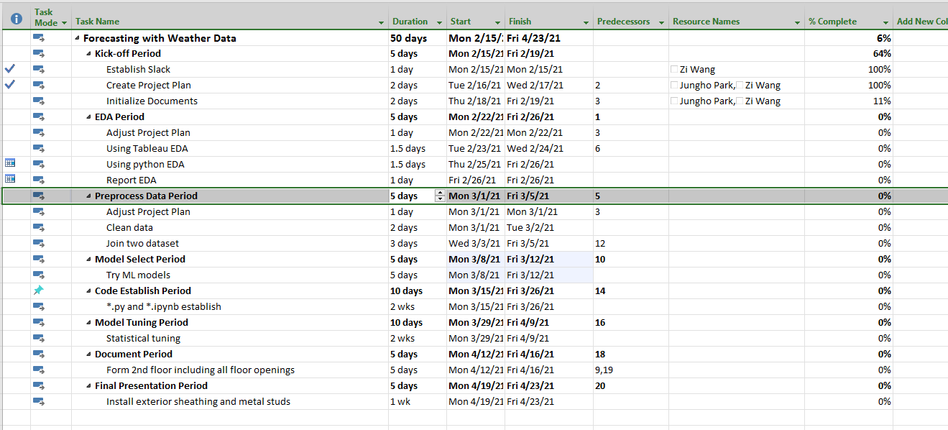



# 5.Meeting Summary

* 1. Feb 17 Meeting Summary
* Create slack
* Find Project Management tools (agile) - Project Planning by Friday
* Professor[Vazacopoulos](https://sit.instructure.com/courses/47171/users/11041) will put data on Slack / might ask for more data during progress
* Weather data & humidity -> using weather data to forecast the processing times for different batches of SKUs
* Visualization & descriptive analysis then do MLFind machine learning articles regarding such problems for implementation.The other 809 project is regarding production planning maybe we can connect both?
* Want to review / progress check-up every Monday
* Remind the recording to professor
* By Friday Meeting
* Zi: Slack setting
* Pranay: Connect with Spray Tek’s employee
* Yi Yi: Choose tech (e.g. python R Tableau)
* Jungho: Find Agile PM tools, possibly setup
  1. Feb 19 Meeting Summary
  2. Feb 22 Meeting Summary

# Platform and Tools

* 1. Coding

For now, we use Python as our coding language.

We need create a GitHub for share documentation and merge code.

For the final presentation, we need to establish a web application (by Django). Every time we extract data from openweather.org, we can get a output.

# 7.Data Visualization

# 8.Current Problem

1.Explan every column meaning of first sheet

2.What output did our customer expect? An web application with input and output?